Exercise 2-2 Image compare

Jirayu Petchhan, D10907801

Data directory

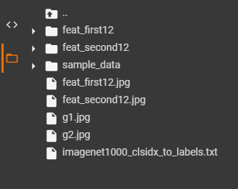

I take one and two class images respectively for testing (g1.jpg, g2.jpg)

|  |  |
| --- | --- |
| C:\Users\e_user\AppData\Local\Microsoft\Windows\INetCache\Content.Word\g1.jpg | C:\Users\e_user\AppData\Local\Microsoft\Windows\INetCache\Content.Word\g2.jpg |
| g1.jpg | g2.jpg |
| My image usage | |
|  | C:\Users\e_user\AppData\Local\Microsoft\Windows\INetCache\Content.Word\bearpug.jpg |
| Pnc.jpg | Bearpug.jpg |

Model trained download usage (ResNet-50)

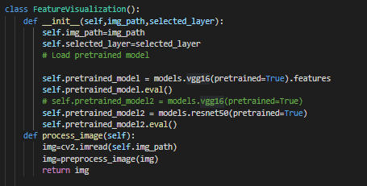



Prediction define function

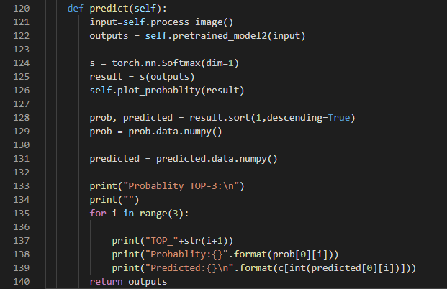

Get class and compare feature map between two classes at the same defined layer (e.g. given layer 12) and compare with two methods i.e. cosine and Euclidean distance.

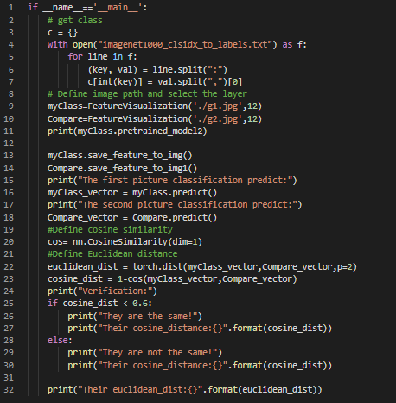

Model printed

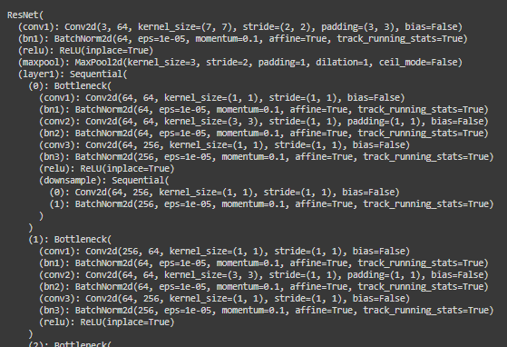

**Provided image (g1 and g2.jpg)**

Probability of class prediction of g1.jpg

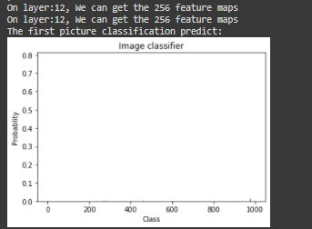

Feature map of g1.jpg



Top-3 of prediction of g1.jpg

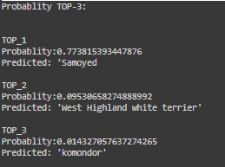

Probability of class prediction of g2.jpg

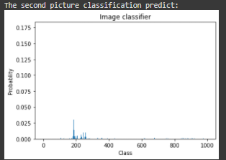

Feature map of g2.jpg



Top-3 of prediction of g2.jpg

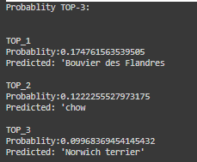

Cosine distance = 0.5910

Euclidean score = 78.14

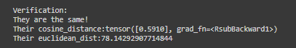

**My image referred (pnc and bearpug.jpg)**

Probability of class prediction of pnc.jpg and top-3 of prediction of pnc.jpg

Feature map of pnc.jpg



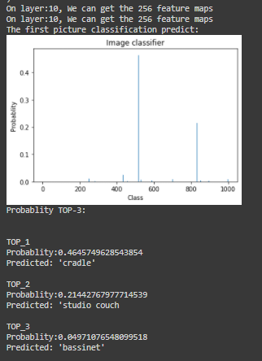

Probability of class prediction of bearpug.jpg and top-3 of prediction of bearpug.jpg

Feature map of bearpug.jpg



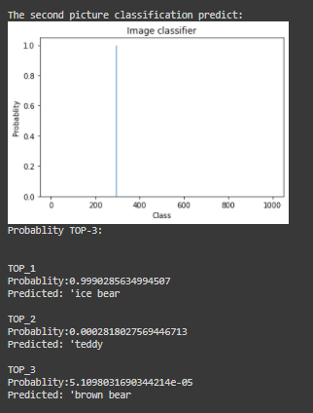

Cosine distance = 0.4485

Euclidean score = 77.2755966

